Sheet A

Sheet B

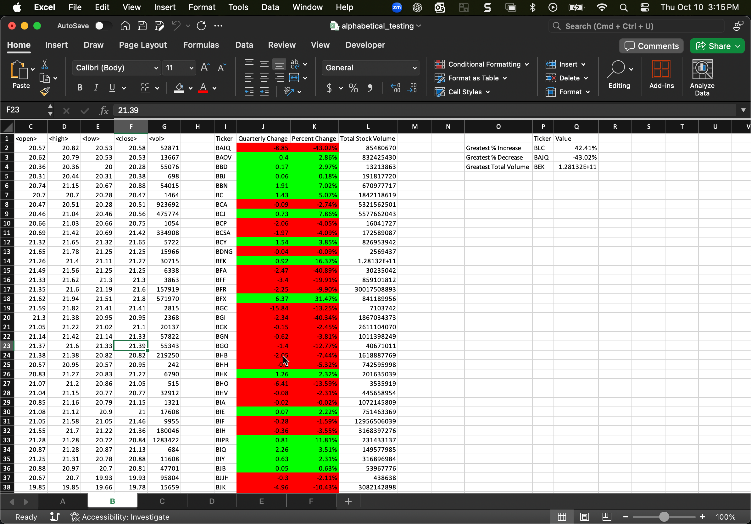

Sheet C

Sheet D

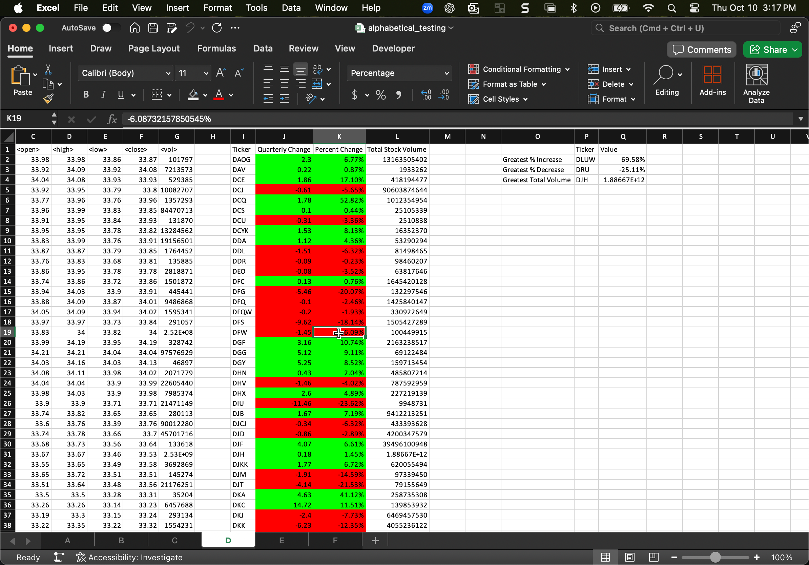

Sheet E

Sheet F

